11930 Cyrus Way
Mukilteo, WA 98275
(425) 263-8000

Notice of Application
for Mukilteo Water and Wastewater District Administrative/Lab Building
at 9417 62nd Place SW
by the Mukilteo Water and Wastewater District

The Mukilteo Water and Wastewater District applied for an Essential Public Facility (EPF) Permit, Shoreline Substantial Development Conditional Use Permit (CUP), and a Shoreline CUP with the City of Mukilteo on August 29, 2018. The application became complete on October 1, 2018. This application and all supporting documents are available at City Hall for public viewing. (File No. EFP-2018-001 / SH-SDP-2018-001 / SH-CUP-2018-001)

Description of Proposal: Demolition of the current administrative/lab building which is one story and has a building footprint of approximately 1,960 square feet. The new administrative/lab building will be a two-story building with the same footprint of 1,960 square feet. The new building will be constructed over an area of existing pavement approximately 25 feet from the existing administrative/lab building. Administrative offices and the lab will be on the top floor with a maintenance shop and storage on the lower floor.

Location of Proposal: See Attachment

Environmental Documents Prepared for the Proposal
- Determination of non-significance (DNS) issued July 23, 2018
- Environmental Checklist dated May, 2018
- Preliminary Geotechnical Report prepared by PanGeo dated July 11, 2018
- Critical Area Study for Big Gulch Wastewater Treatment Facility prepared by Wetland Resources, Inc. dated July 17, 2018

Mukilteo Water and Wastewater District, as the designated lead agency for State Environmental Policy Act (SEPA), has issued a DNS for the proposed project on July 23, 2018. No appeals of the DNS were filed and the SEPA determination stands as issued. No additional review under SEPA is required.

List of Required Permits:
- EPF Permit
- Shoreline Substantial Development CUP
- Shoreline CUP
- Building Permit
- Engineering Permit
- Any State and Federal Permits if applicable

Applicable Policies and Requirements
The project will be reviewed for consistency with the following policies, standards and regulations:

Possession Shores Master Plan | Sector Plan & Amendments
Comprehensive Plan, Shoreline Master Plan | Mukilteo Municipal Code
International Building Code (2015 Edition) | City of Mukilteo Development  Standards
International Fire Code (2015 Edition)
Comment Period
The application and supporting documents are available for review at the City of Mukilteo, 11930 Cyrus Way, Mukilteo, WA 98275. Contact: Linda Ritter at (425) 263-8043. The public is invited to comment on the project by submitting written comments to the Planning Department at the above address by 4:30 p.m. on the date noted below.

Notice of Application Issued: Friday, October 12, 2018
End of Comment Period: Tuesday, November 13, 2018

The City will not act on this application until the end of the 30-day shoreline permit public comment period. Upon completion of project review the proposed application will be scheduled for a public hearing with the Mukilteo Hearing Examiner where the project will be approved, approved with conditions, or denied. You may request a copy of the final decision on the project by making a written request to the City contact person named below.

Public Hearing
There will be a public hearing conducted on this project. You have the right to request notice of and to participate in the public hearing. If you want to receive notice of the hearing, you may make a written request to the City contact person named below.

Appeals
Any person aggrieved by the granting, denying, or rescinding of a permit on shorelines of the state pursuant to RCW 90.58.140 may seek review from the shorelines hearings board by filing a petition for review within twenty-one days of the date of filing as defined in Chapter 90.58 RCW. Only persons who file written comments on the project in response to the Notice of Application are considered parties of record who may appeal the decision. If you do not file written comments within the comment period, you may not appeal the final decision.

Contact Person: Linda Ritter, Senior Planner (425) 263-8043

Signature: ____________________ Date: ______________________
Linda Ritter, Senior Planner

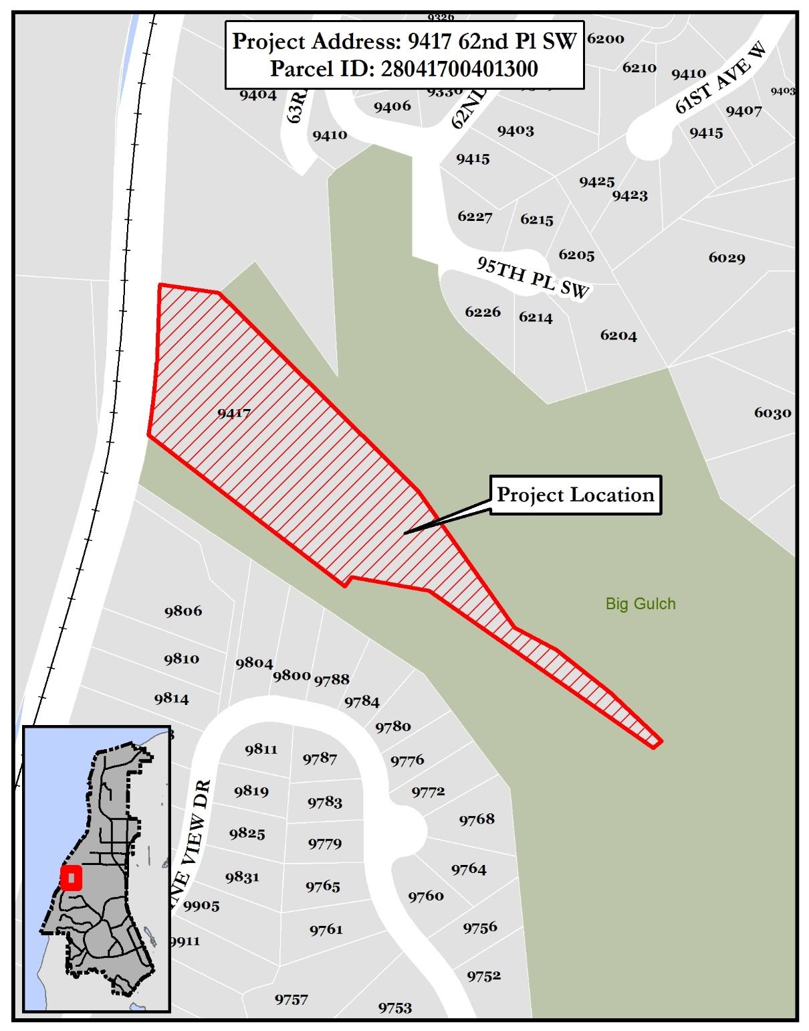
Location Map

Date Issued: Friday, October 12, 2018

Date Advertised: Friday, October 12, 2018
End Comment Period: Tuesday, November 13, 2018

pc: | Applicant/Representative | CDD Director | Property File
 | Reviewing Agencies | Permit Services Supervisor | Property Owners (300’)
 | Interested Parties | Permit Services Assistants (2)

11930 Cyrus Way, Mukilteo WA

Notice of Application Summary
Mukilteo Water and Wastewater District Administrative/Lab Building
at 9417 62nd Place SW
by the Mukilteo Water and Wastewater District

Project Information: Demolition of the current administrative/lab building which is one story and has a building footprint of approximately 1,960 square feet. The new administrative/lab building will be a two-story building with the same footprint of 1,960 square feet. The new building will be constructed over an area of existing pavement approximately 25 feet from the existing administrative/lab building. Administrative offices and the lab will be on the top floor with a maintenance shop and storage on the lower floor.

Environmental Documents Prepared for the Proposal:
- Determination of non-significance (DNS) issued July 23, 2018
- Environmental Checklist dated May, 2018
- Preliminary Geotechnical Report prepared by PanGeo dated July 11, 2018
- Critical Area Study for Big Gulch Wastewater Treatment Facility prepared by Wetland Resources, Inc. dated July 17, 2018

Mukilteo Water and Wastewater District, as the designated lead agency for State Environmental Policy Act (SEPA), has issued a DNS for the proposed project on July 23, 2018. No appeals of the DNS were filed and the SEPA determination stands as issued. No additional review under SEPA is required.

The public is invited to comment on the project by submitting written comments to the Planning Department at the above address by 4:30 p.m. on November 13, 2018. You are receiving this notice because you are within the noticing area for this project. To obtain a complete Notice of Application contact the City at (425) 263-8000 go to our website:
http://www.mukilteowa.gov/Land-Use-Action-Notice

