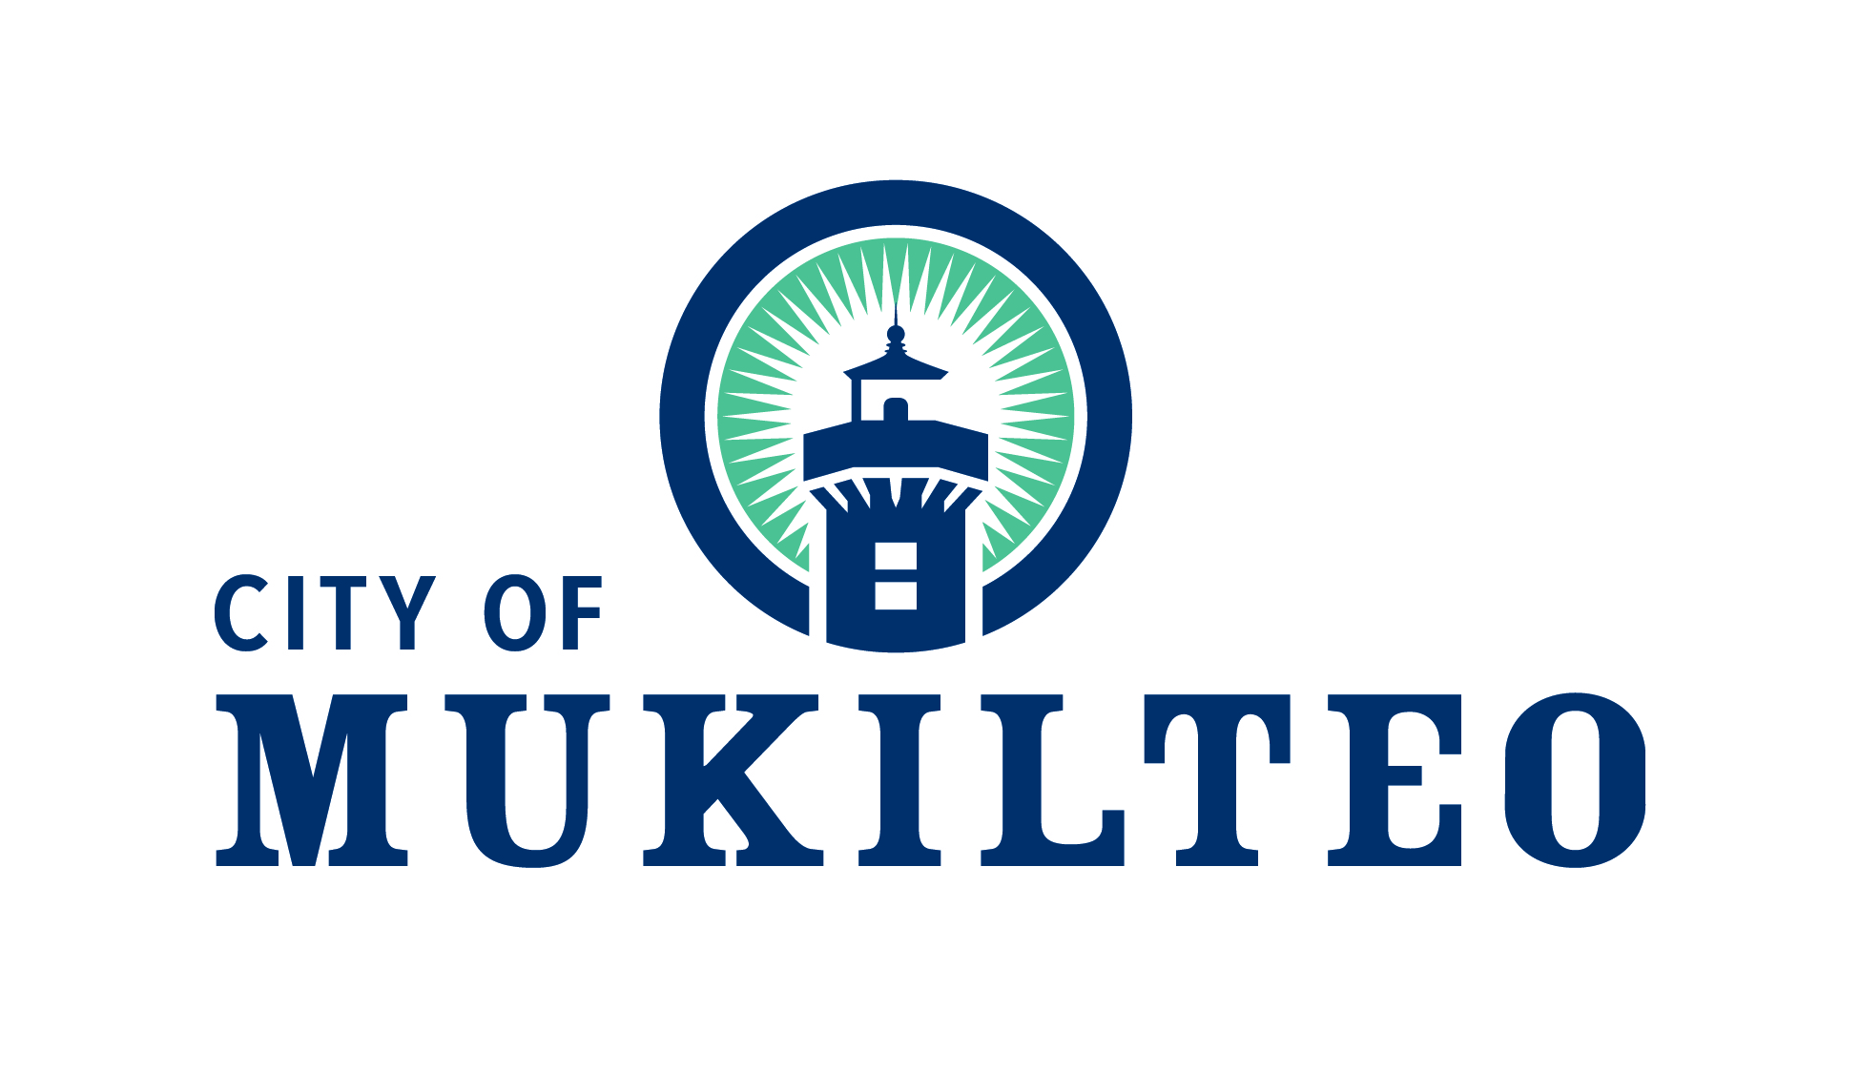
Land Use & Economic Development Committee

Tuesday, May 4, 2021
5:30 PM - 7:00 PM

(MEETING HELD VIA ZOOM)

Meeting Notes

Land Use & Economic Development Committee Attendees
Present: Councilmember Marine (left meeting at 6:00pm)
Councilmember Harris
Councilmember Emery

Other Attendees
Economic Alliance Snohomish County President and CEO Garry Clark
Mukilteo Chamber of Commerce President and CEO Kandace Barnes
Mayor Gregerson
City Administrator Powers
Community Development Director Osaki

CALL TO ORDER - 5:30 PM

- Economic Alliance Snohomish County - Garry Clark
At the invitation of the Land Use & Economic Development (LU&ED) Committee, Economic Alliance Snohomish County (“EASC”) new President and CEO Garry Clark was in attendance.

Mr. Clark discussed his background and how 2021 is EASC’s ten year anniversary. EASC is working on a five-year goal for the county and region centered around issues such as, but not limited to:

- Workforce Development
- Advocacy
- Business Retention
- Quality of life (e.g. housing, transportation, infrastructure, Diversity, Equity and Inclusion (DEI)

Mr. Clark mentioned Snohomish County exists because of its communities. For that reason, EASC wants to listen to communities with an emphasis on how EASC can support “you”, the communities.

Mr. Clark added that communication is essential. No one should assume that everyone knows what is going on regarding economic development. He wants to hold monthly meetings among communities to project transparency. Mukilteo needs to be open about what it needs.

Mr. Clark also emphasized the importance of planning in economic development. Everyone needs a plan. The plan needs to recognize people, infrastructure and advance our talent. We want to be an entrepreneurial hub.

Transportation, housing and infrastructure are key components to economic development planning, as is diversity, equity and inclusiveness (DEI). DEI expands our opportunities to change, innovate and learn.

Mr. Clark talked about developing a local economic development strategy. The method by which you bring people together is critical and he referenced a “strategic doing” concept for collaboration.

A local economic development effort should identify:

- The community’s primary economic development goal (e.g. business retention, leveraging, local incentives);
- Economic development tools that are available to the municipality;
- Locations within the community that offer opportunities for economic development.

The process should involve brainstorming amongst community leaders and constituents with at least 60 people. This process is also best done with the assistance of an outsider.

Mr. Clark discussed the EASC some more. The EASC currently has 14 FTE and is looking to add a couple of more positions. He mentioned that EASC has a long range campaign to 2025.

Councilmember Harris mentioned that Mukilteo is in the shadow of the Paine Field and has to deal with infrastructure needs of Paine Field versus the impacts to the community.

In response, Garry Clark suggested that the City talk directly to the leadership of Paine Field and make a “direct ask”.

With regards to tourism, Mr. Clark mentioned that upon visiting Snohomish County he noticed the beauty of Mukilteo and Snohomish County as a whole. He recognizes tourism is one of our largest industries. Other cities do not share the amenities and natural features Mukilteo has. Mukilteo should build this up. It is a huge opportunity.

- Economic Recovery
Mukilteo Chamber of Commerce President and CEO Kandace Barnes mentioned that one of the main issues of the business community was advocating for the County to remain in Phase 3 of the Governor’s reopening plan rather move back to Phase 2.

She added that various chambers of commerce had talked to Governor Inslee’s staff during the past week about the importance of staying in Phase 3 and avoiding the roller coaster of phases.

American Rescue Plan (ARP) Funding
Mayor Gregerson mentioned meetings at the County level that discussed use of American Rescue Plan (ARP) funds. Discussion seems to be moving away from using federal funds for direct business grants and instead using the funds to focus on resiliency. Examples might be to hire an individual to provide direct assistance to solve specific business issues and needs.

Mukilteo Chamber of Commerce President and CEO Kandace Barnes noted that long-term sustainability is important to small businesses, including how we conduct long term planning to support businesses in the future. For example, to support hotels, how do we get people into the City in the next year and beyond and have these people stay in hotels longer? Also, how might we create events like a “restaurant week”.

The LU&ED Committee expressed interest in using ARP funds to develop a strong economic development vision for the future and put it into action.

Councilmember Emery mentioned looking into a local currency program - creation of a local form of currency that is used and accepted within a community to support locally-owned businesses within a geographically defined market. Tenino, Washington was mentioned as an example where this has been done.

- Other

There was brief discussion about the role of the Land Use & Economic Development Committee in actively reviewing development applications. While the Land Use & Economic Development Committee is interested in knowing about what development projects are proposed, it concurred that it should not be reviewing them.

It was mentioned that information about development applications is made available on the City website, notices are now available on social media, and that the Mayor’s weekly reports frequently mention new development applications. Longer term, staff is looking at building a web page with a map that identifies active development projects.
Director Osaki mentioned that in the past staff has briefed the LU&ED Committee on development projects taking place in the City. This was done as a matter of information. Staff will do that again at a future LU&ED Committee meeting.

ADJOURNMENT - 7:00 PM

Next Meeting Date/Time: Tuesday, June 1, 2021, 5:30PM

